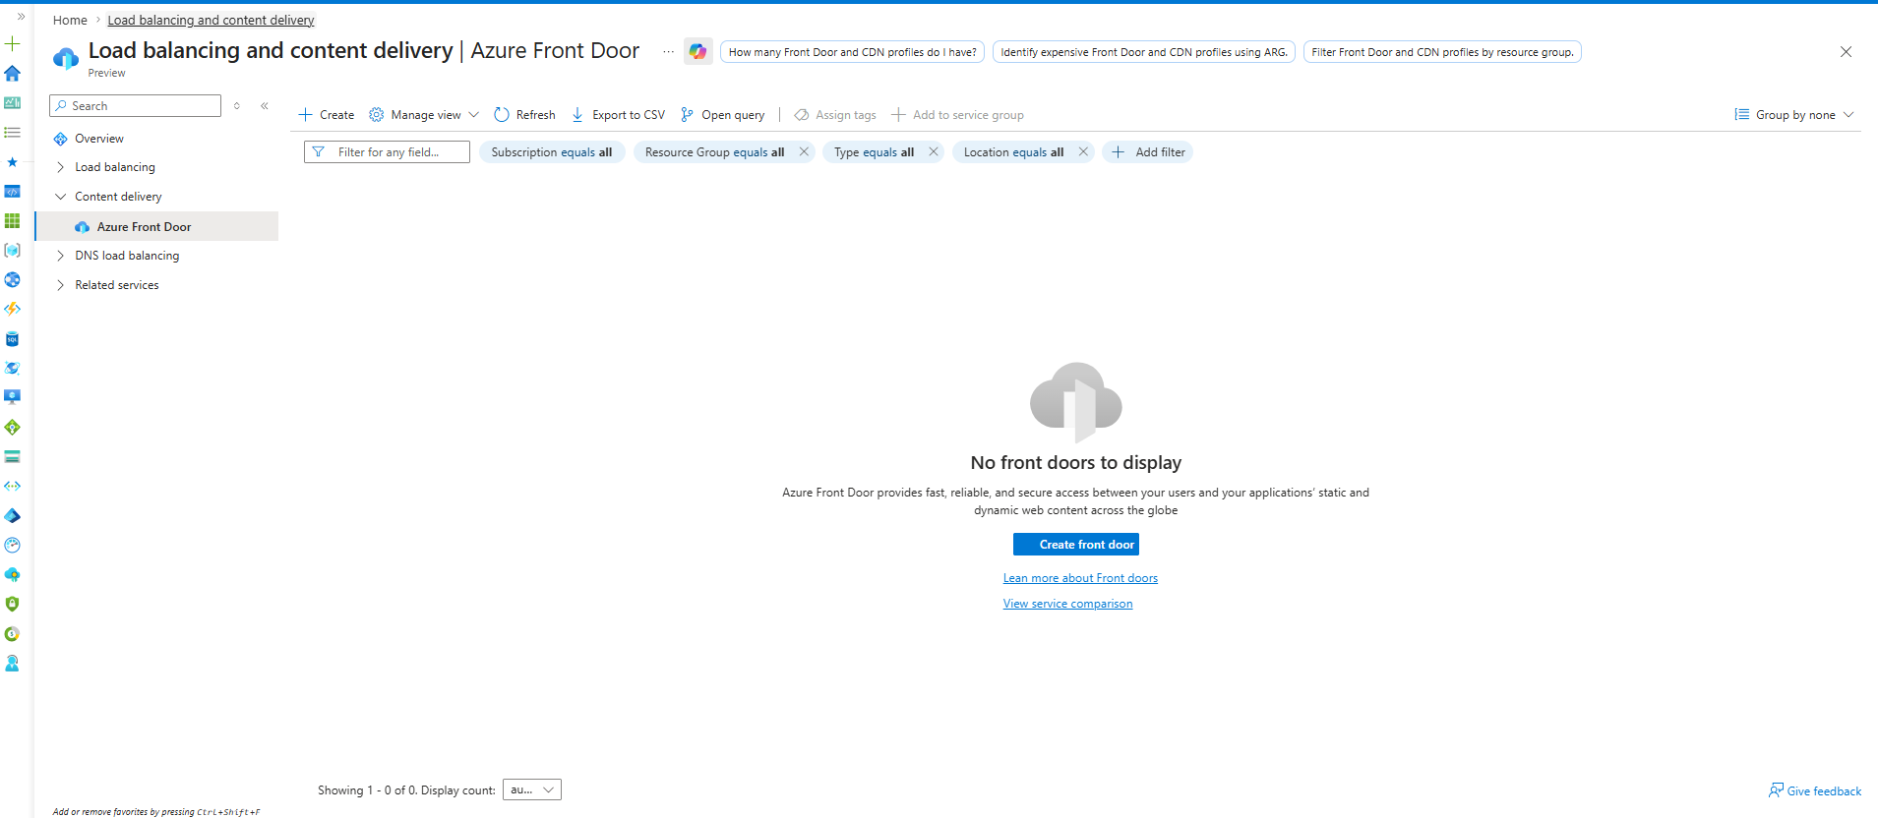Azure Front Door
----------------
Definition:
Global Layer 7 traffic management service that routes users to the nearest and healthiest backend region.

Usage:
Global applications, disaster recovery, low-latency access, and multi-region deployments.

If Not Used:
Higher latency, difficult failover management, and poor user experience for global users.

Main Components:
Frontend Host
Backend Pool (Origin Group)
Health Probe
Routing Rule

Routing Methods:
Latency Routing
Priority Routing
Weighted Routing

Main Purpose:
Route users to the best Azure region.

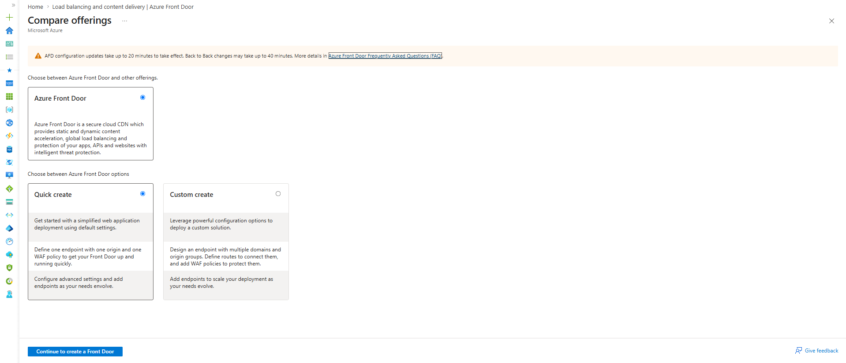
Azure Front Door
You selected:
Azure Front Door
Definition
- Global Layer 7 traffic management service.
- Routes users to the nearest and healthiest region.
Usage
India User → India Region
USA User → USA Region
Europe User → Europe Region
If Not Used
USA User
↓
India Region
Higher latency.

Quick Create vs Custom Create

Quick Create
Definition
- Simplified deployment.
Usage
1 Endpoint
1 Origin
1 Route
1 WAF Policy
Azure creates most settings automatically.
Good For
Learning
POC
Testing

Custom Create
Definition
- Full control over Front Door components.
Usage
You manually configure:
Endpoints
Origin Groups
Origins
Routes
WAF
Domains
Good For
Production
Enterprise
Multi-region apps

Why Microsoft Mentions CDN?
Look at the description:
Static and Dynamic Content Acceleration
This is why people compare it to CloudFront.

Normal Application Request
Without Front Door:
India User
↓
USA Server
Long distance.

Front Door Edge Location
With Front Door:
India User
↓
Nearest Microsoft Edge POP
↓
Microsoft Global Network
↓
USA Backend
Traffic travels through Microsoft's backbone network.
Faster than public internet.

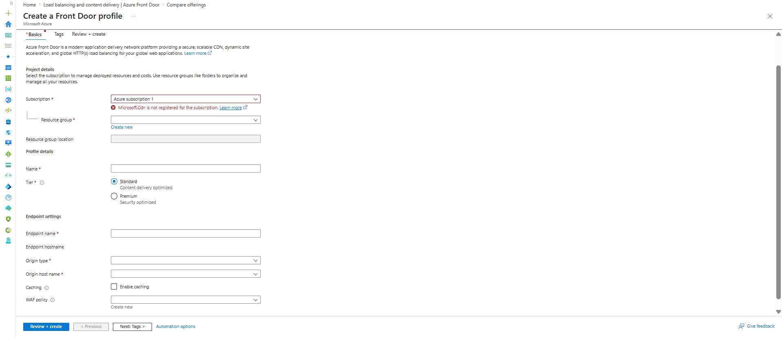
Profile Name
Definition
Logical name of the Front Door profile.
Usage
Container for:
Endpoints
Origin Groups
Routes
WAF Policies
Example
company-frontdoor
global-frontdoor
prod-frontdoor
Think:
Application Gateway
-----------
One Gateway Resource
Front Door
-----------
One Front Door Profile

Tier
You have:
Standard
Premium

Standard
Usage
Global Routing
Caching
HTTPS
Health Probes
Load Balancing
Enough for most applications.

Premium
Usage
Everything in Standard plus:
Private Link
Advanced Security
Enterprise Features

Endpoint Name
This is the first important Front Door component.
Definition
Public entry point for users.
Usage
Users connect here.
Example:
mycompany.azurefd.net

Think:
Application Gateway
-------------
Frontend IP
Front Door
-----------
Endpoint
Equivalent concept.

Endpoint Hostname
Azure automatically generates:
endpoint.azurefd.net
Users access through this hostname.

Origin Type
This is another important concept.
Definition
Backend type that receives traffic.
Examples
Application Gateway
App Service
Storage Account
Public IP
VM

Think:
Application Gateway
------------
Backend Pool
Front Door
-----------
Origin

Origin Host Name
Definition
Actual backend endpoint.
Example:
app.contoso.com
20.100.10.10
myapp.azurewebsites.net

Caching
This is where Front Door becomes similar to CloudFront.
Definition
Stores frequently requested content at edge locations.
Usage
Static content:
Images
CSS
JavaScript
Videos

Without Cache:
User
↓
Front Door
↓
Origin Server
Every request hits backend.

With Cache:
User
↓
Nearest Edge Location
↓
Cached Response
Faster.

WAF Policy
Same concept you learned in Application Gateway.
Definition
Protects web applications from attacks.
Usage
SQL Injection
XSS
Bot Protection

Most Important Mapping
Application Gateway:
Frontend IP
Backend Pool
Routing Rule
Front Door:
Endpoint
Origin
Route

Big Picture Architecture
Users Worldwide
↓
Front Door Endpoint
↓
Route
↓
Origin Group
↓
--------------------------------
| | |
India USA Europe
Origin Origin Origin

One-Line Memory Trick
Application Gateway
-------------------
Routes to the correct application.
Azure Front Door
----------------
Routes to the correct region.

What is Azure Traffic Manager?
Definition:
Azure Traffic Manager is a DNS-based traffic routing service that directs users to the best available endpoint.
Usage:
Used when the same application is deployed in multiple regions and you want users to reach the best region automatically.
If not used:
All users may hit a single region, causing higher latency and no regional failover.
Example:
- App in India
- App in US
- App in UK
Traffic Manager decides which region the user should connect to.
User
|
Traffic Manager (DNS)
|
+---- India App
+---- US App
+---- UK App

User
|
Traffic Manager (DNS)
|
+---- India Region
| |
| App Gateway
| |
| VMs
|
+---- US Region
|
App Gateway
|
VMs

Load Balancer vs Traffic Manager
Load Balancer
- Routes traffic between VMs.
- Works inside Azure network.
- Uses IP and ports.
- Regional service.
Traffic Manager
- Routes users to different regions.
- Works using DNS.
- Doesn't see actual traffic.
- Global service.
Front Door vs Traffic Manager
This is the most important interview question.
Traffic Manager
- DNS based routing.
- User gets region IP and connects directly.
- Cannot inspect HTTP requests.
- No SSL termination.
- No WAF.
Front Door
- HTTP/HTTPS proxy.
- Traffic first reaches Front Door.
- Can do path-based routing.
- SSL termination.
- WAF support.
- Global load balancing.
When to Use
Load Balancer
- Multiple VMs in one region.
Application Gateway
- Web applications needing URL/path routing.
Front Door
- Global web applications with WAF and acceleration.
Traffic Manager
- Route users to the nearest or healthiest Azure region.
Easy Memory
Traffic inside VMs
↓
Load Balancer
Traffic inside Web Apps
↓
Application Gateway
Global Web Traffic
↓
Azure Front Door
Global Region Selection
↓
Traffic Manager

Most Important Point
Traffic Manager is NOT a Load Balancer.
Load Balancer receives traffic.
Traffic Manager never receives traffic.
It only answers DNS queries.
Example:
www.company.com
|
v
Traffic Manager
|
Returns:
20.10.10.10 (India)
After getting the IP:
User --------> India App
Traffic never goes through Traffic Manager.

Real Flow
Suppose user opens:
www.netflix.com
Step 1:
Browser asks DNS:
Where is www.netflix.com?
Step 2:
Traffic Manager checks routing rules.
Step 3:
Traffic Manager returns:
India Endpoint IP
Step 4:
Browser directly connects to India endpoint.
User -----> India Endpoint
Traffic Manager's job is finished.

Components of Traffic Manager
1. Profile
Definition:
A Traffic Manager configuration container.
Usage:
Stores routing method, endpoints, monitoring settings.
If not created:
Traffic Manager cannot work.
Example:
TM-Profile
├─ Routing Method
├─ Endpoints
└─ Health Checks

2. Endpoint
Definition:
Actual destination resources.
Usage:
Where users are routed.
If not configured:
No target exists.
Examples:
- App Service
- Public IP
- Application Gateway
- Front Door
- External website
Traffic Manager
|
+---+---+
| |
India US

3. Health Check
Definition:
Traffic Manager continuously checks endpoint health.
Usage:
Detects failures.
If not enabled:
Users may be routed to a dead application.
Example:
Traffic Manager
|
Health Probe
|
India App

Routing Methods
These are extremely important for interviews.
1. Priority Routing
Definition:
Always send traffic to primary endpoint.
Usage:
Disaster Recovery.
If primary fails:
Traffic goes to backup.
Example:
Priority 1 → India
Priority 2 → US
Priority 3 → UK
Normal:
All Users → India
India down:
All Users → US

2. Weighted Routing
Definition:
Traffic distributed based on assigned weights.
Usage:
Testing new versions.
Example:
India = 80
US = 20
Result:
80% Users → India
20% Users → US
Useful for blue-green deployments.

3. Performance Routing
Definition:
Routes users to the lowest latency region.
Usage:
Global applications.
Example:
India User → India Region
US User → US Region
UK User → UK Region
Users get better response times.

4. Geographic Routing
Definition:
Routes users based on geographic location.
Usage:
Compliance and data residency requirements.
Example:
India Users → India App
Europe Users → Europe App
US Users → US App

5. MultiValue Routing
Definition:
Returns multiple healthy endpoints.
Usage:
Applications handling failover themselves.
Example:
Returns:
IP1
IP2
IP3
Client chooses one.

6. Subnet Routing
Definition:
Routes based on source IP ranges.
Usage:
Special enterprise network requirements.
Example:
10.1.x.x → Endpoint A
10.2.x.x → Endpoint B

Health Monitoring
Traffic Manager keeps checking:
https://app.contoso.com/health
Expected:
200 OK
If failed repeatedly:
Endpoint = Unhealthy
Traffic automatically moves elsewhere.

Complete Architecture
Users
|
Traffic Manager
|
+--+----------------+
| |
India Region US Region
| |
Application Application
Gateway Gateway
| |
VMs VMs
If India fails:
Users
|
Traffic Manager
|
US Region
|
Application Gateway
|
VMs
No manual action required.

Traffic Manager vs Front Door
Feature | Traffic Manager | Front Door
Works at | DNS Layer | HTTP/HTTPS Layer
Receives traffic | No | Yes
WAF | No | Yes
SSL Termination | No | Yes
Path Based Routing | No | Yes
Global Routing | Yes | Yes
Health Monitoring | Yes | Yes
Easy Interview Answer
Load Balancer → distribute traffic among VMs.
Application Gateway → Layer 7 routing, SSL termination, WAF.
Azure Front Door → Global HTTP/HTTPS entry point with WAF and acceleration.
Traffic Manager → DNS-based service that routes users to the best Azure region based on routing rules and endpoint health.
Before moving to Traffic Manager configuration screens, make sure this distinction is crystal clear:
Front Door receives traffic and forwards it.
Traffic Manager never receives traffic; it only returns DNS answers.

Here is the complete enterprise architecture flow using Traffic Manager + Front Door + Application Gateway + Load Balancer.
Internet Users
|
|
Traffic Manager
(DNS Routing)
|
+----------------+----------------+
| |
India Region US Region
| |
| |
Azure Front Door Azure Front Door
(Global HTTP/HTTPS) (Global HTTP/HTTPS)
| |
| |
Application Gateway Application Gateway
(WAF + SSL Termination) (WAF + SSL Termination)
| |
| |
Load Balancer Load Balancer
(Layer 4) (Layer 4)
| |
+-----+-----+ +-----+-----+
| | | |
VM1 VM2 VM1 VM2
| | | |
+-----------+ +-----------+
| |
Database Database
Step-by-Step Request Flow
Step 1: User Opens Website
www.company.com
Browser first performs DNS lookup.

Step 2: Traffic Manager
Traffic Manager checks:
- Health of regions
- Routing method
- Priority/Performance/Weighted rules
Example:
India user
|
Traffic Manager
|
Returns India Front Door
Traffic Manager's job ends here.

Step 3: Azure Front Door
User now connects to Front Door.
Front Door performs:
- Global load balancing
- SSL termination
- WAF inspection
- URL routing
- CDN acceleration
Example:
/api/*
send to API backend.
/images/*
send to Image backend.

Step 4: Application Gateway
Front Door forwards traffic to Application Gateway.
Application Gateway performs:
- WAF protection
- SSL offloading
- Host-based routing
- Path-based routing
Example:
/app1
→ Backend Pool 1
/app2
→ Backend Pool 2

Step 5: Load Balancer
After reaching backend pool:
Application Gateway
|
Load Balancer
Load Balancer distributes traffic.
Example:
Request 1 → VM1
Request 2 → VM2
Request 3 → VM3

Step 6: Application VM
Application processes request.
VM
|
Application
|
Database
Response generated.

Step 7: Response Back
Database
|
Application
|
Load Balancer
|
Application Gateway
|
Front Door
|
User

What Each Service Solves
Traffic Manager
Problem:
Which Azure region should user go to?
Example:
India User → India Region
US User → US Region

Front Door
Problem:
Global entry point for web applications.
Example:
Nearest Microsoft Edge POP
reduces latency.

Application Gateway
Problem:
How to route requests inside a region?
Example:
/api → API Servers
/web → Web Servers

Load Balancer
Problem:
How to distribute traffic among servers?
Example:
VM1
VM2
VM3

Real Interview One-Liner
Traffic Manager
↓
Select Best Region
Azure Front Door
↓
Global Web Entry Point
Application Gateway
↓
Web Routing + WAF + SSL
Load Balancer
↓
Distribute Traffic Across VMs
Application
↓
Database
This is the complete end-to-end traffic flow from an internet user all the way to the backend servers in a typical enterprise Azure architecture.

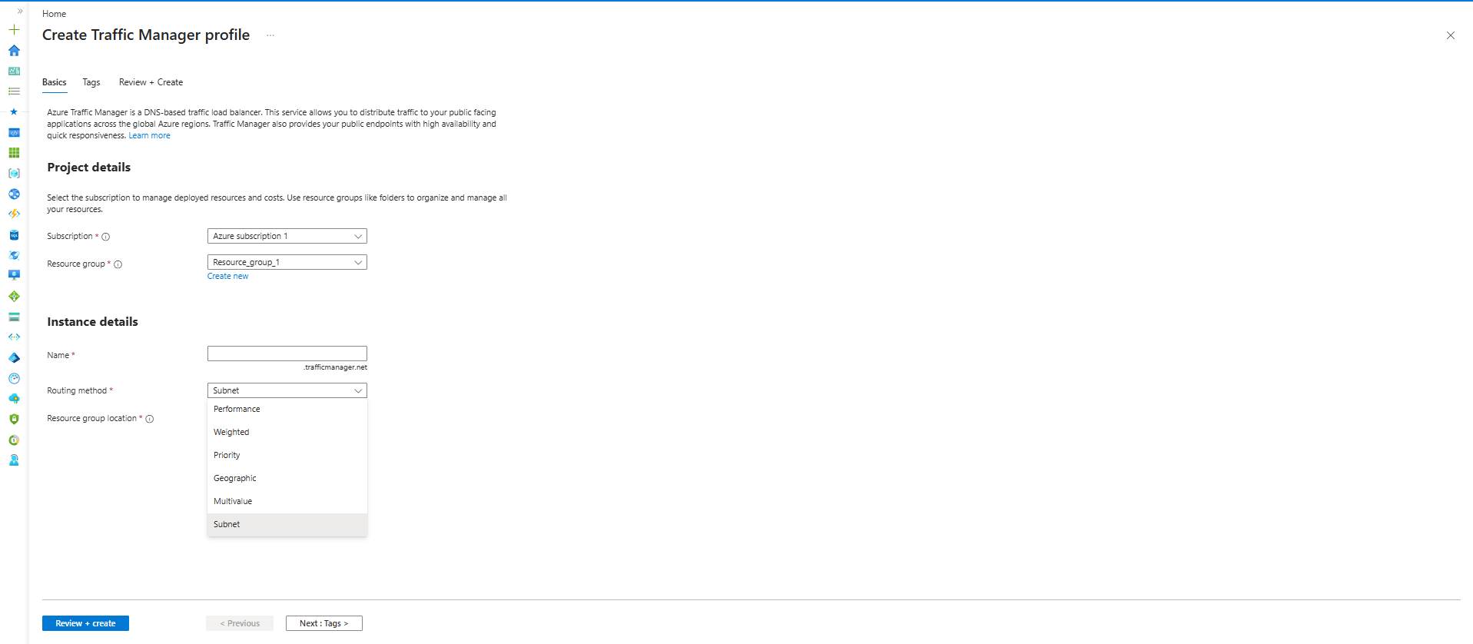
This screen only creates the Traffic Manager Profile and asks:
"Which routing method do you want to use?"
For example, if you select:
Routing Method = Weighted
and create the profile, Azure creates an empty Traffic Manager profile.
After deployment:
Traffic Manager Profile
|
+-- Endpoints
Then you add endpoints and configure weights.

Weighted Routing
After creating the profile:
Traffic Manager
|
+-- India Endpoint
+-- US Endpoint
While adding endpoints you'll see:
Weight
Example:
India = 80
US = 20
Traffic Manager sends:
80% → India
20% → US

Priority Routing
After profile creation:
India Endpoint
Priority = 1
US Endpoint
Priority = 2
UK Endpoint
Priority = 3
Traffic Manager always uses:
Priority 1
If it fails:
Priority 2

Geographic Routing
After adding endpoints:
India Endpoint
Location = India
US Endpoint
Location = United States
Europe Endpoint
Location = Europe
Traffic Manager maps users according to country/region.

Subnet Routing
After adding endpoints:
Endpoint A
10.0.0.0/24
Endpoint B
20.0.0.0/24
Traffic Manager checks source IP range and returns the matching endpoint.

Multivalue Routing
You simply add multiple endpoints.
Example:
Endpoint1
Endpoint2
Endpoint3
Traffic Manager returns multiple healthy IPs in DNS response.

Performance Routing
This is what your screenshot currently shows.
Routing Method = Performance
Here you don't configure weights or priorities.
Azure automatically uses its latency table.
Example:
India User → India Endpoint
US User → US Endpoint
Japan User → Japan Endpoint
based on lowest latency.

Interview Point
Think of this screen as:
Step 1:
Create Traffic Manager Profile
Step 2:
Choose Routing Method
Step 3:
Deploy
Step 4:
Add Endpoints
Step 5:
Configure
- Weight
- Priority
- Geography
- Subnet

